

# ACTIVITY SHEET 1

### Pemulwuy

Instructions

Read each source, use a dictionary or ask your teacher about words you don’t understand.

Put the sources in the correct order, then use some of the information from the sources to make a timeline of Pemulwuy’s life.

SOURCE A

On 25th January 1795 we found that the natives were assembling in numbers for the purpose of performing a ceremony. Several youths well known among us, never having submitted to the operation [circumcision] were now to be made men. Pe-mul-wy, a wood native, and many strangers, came in [to Farm Cove in Sydney].

Source: Collins, D. An Account of the English Colony of New South Wales, Vol 1.

SOURCE B

The natives . . . plundered many of the settlers, wantonly murdered four white men and cruelly used some of the convict women . . . The natives about Sydney and Hawkesbury continued as domesticated as ever, and reprobated [condemned] the conduct of the natives in the neighbourhood of Parramatta and Toongabbee, who were irritated by an active, daring leader named Pemulwuy . . .

I gave orders for every person doing their utmost to bring Pemulwuy in, either dead or alive . . . Some time after, two settlers, not having the means of securing the persons of Pemulwuy and another native, shot them.

Source: Governor King to Lord Hobart, 30th October 1802

SOURCE C

Several tribes of the natives still continuing to throw spears at any man they meet unarmed, by which several have been killed or dangerously wounded, the Governor, in order to deter the natives from such practices in the future, has ordered out a party to search for the man who wounded the convict [McEntire] in so dangerous a manner . . . and to make a severe example of that tribe . . .

A party consisting of 2 captains, 2 subalterns and 40 privates with a proper number of non-commissioned officers from the garrison, with three days’ provision etc, to be ready to go out tomorrow morning at daylight, in order to bring in six of those natives who reside near the head of Botany Bay, or if that number should be found impracticable, to put that number to death.

Source: Governor Phillip’s General Orders, 13th December 1790



# ACTIVITY SHEET 1

### Pemulwuy

SOURCE D

Pemulwuy, or some of his party, were not idle about Sydney; they even ventured to appear within half a mile of the brickfield huts, and wound a convict who was going to a neighbouring farm on business.

May, 1795

Source: Collins, D. An Account of the English Colony of New South Wales, Vol

SOURCE E

This detachment [of soldiers] is to prevent the natives from firing the wheat, for which purpose a private will patrol occasionally from daylight till nine o’clock at night . . . They are to fire on [shoot at] any natives they see, and if they can, pursue them with a chance of overtaking them. Every means is to be used to drive them off, either by shooting them or otherwise.

It being known that William Knight and Thomas Thrush [outlaws] and the native, Pemulwoy, are the promoters of the outrageous acts that have been lately committed by the natives, whereby two men have been killed, several dangerously wounded, and numbers robbed, the reward* advertised on the 17th inst [this month] will be given to those who will bring the above delinquents in, dead or alive . . .

*The reward included 20 gallons of rum and two suits of clothes to a free man and a pardon for someone serving 14 years or life.

Source: Governor King’s Government and General Orders, 22nd November 1801

SOURCE F

Having proceeded down the river, they stopped at a point near Botany bay, where they met with several parties of natives among whom was Pe-mul-wy, who, having recovered from his wounds, had escaped from the hospital with an iron about his leg.

1798

Source: Collins, D. An Account of the English Colony of New South Wales, Vol II.



# ACTIVITY SHEET 1

### Pemulwuy

SOURCE G

. . . they saw two natives, with spears in their hands, creeping towards them, and three others a little farther behind . . . McEntire said “Don’t be afraid, I know them,” and immediately laying down his gun, stepped forward and spoke to them in their own language . . . One of them jumped on a fallen tree, and without giving the least warning of his intention, launched his spear at McEntire and lodged it in his left side. The person who committed this wanton act, was described as a young man with a speck, or blemish, on his left eye. . .

In the course of the day, Colbee and several more natives came in . . . Their behaviour indicated that they had already heard of the accident, as they repeated twice or thrice the name of the murderer, Pim-el- wi, saying that he lived at Botany Bay.

Source: December 1790Tench, W, Sydney’s First Four Years, December 1790

SOURCE H

From the wanton manner in which a large body of natives resident about Parramatta, George’s River and Prospect Hill, have attacked and killed some of the Government sheep, and their violent threat of murdering all white men they meet, which they put into execution by murdering Daniel Conroy, stock- keeper, . . . and severely wounding Smith, settler: and it is impossible to foresee to what extent their present hostile menaces may be carried, both with respect to the defenceless settlers and the stock, the Governor has directed that this, as well as other bodies of natives in the above district, to be driven back from settlers’ habitations by firing at them.

Source: Governor King’s Government and General Orders, 1st May 1801



# ACTIVITY SHEET 1

### Pemulwuy

SOURCE I

A strange idea was found to prevail among the natives respecting the savage Pe-mul-wy, which was very likely to prove fatal to him in the end. Both he and they entertained an opinion, that, from his having been frequently wounded, he could not be killed by our fire-arms. Through his fancied security, he was said to be at the head of every party that attacked the maize grounds.

Source: Collins, D. An Account of the English Colony of New South Wales, Vol II, March 1798

### Pemulwuy

SOURCE J

. . . the soldiers entered the town [Parramatta], and in about an hour after were followed by a large body of natives, headed by Pe-mul-wy, a riotous and troublesome savage. These were known by the settlers to be the same who had so frequently annoyed them; and they intended, if possible, to seize upon Pe-mul- wy; who, in a great rage, threatened to spear the first man that dared to approach him, and actually did throw a spear at one of the soldiers. The conflict was now begun; a musket was immediately levelled at the principal [Pemulwuy], which severely wounded him . . .

Pe-mul-wy, who had received seven buck shot in his head and different parts of his body, was taken extremely ill to the hospital. This man was first known in the settlement by the murder of John McIntire in the year 1790; since which time he had been a most active enemy to the settlers, plundering them of their property and endangering their personal safety.

Source: Collins, D. An Account of the English Colony of New South Wales, Vol II., March 1797

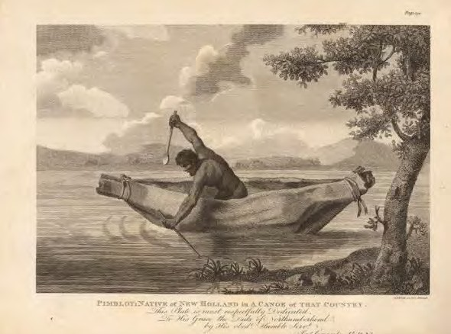

# ACTIVITY SHEET 1

Timeline of Pemulwuy’s Life

Figure 56: Plate 3. ‘Pimbloy 1804’, thought to be Pemulwuy, from James Grant, Narrative of a Voyage of Discovery. Image from the National Library of Australia.

|  |  |
| --- | --- |
| Dates | Events |
|  |  |
|  |  |
|  |  |
|  |  |
|  |  |
|  |  |

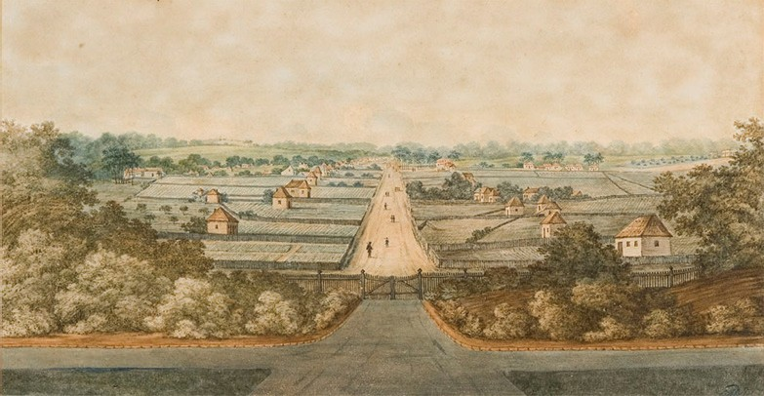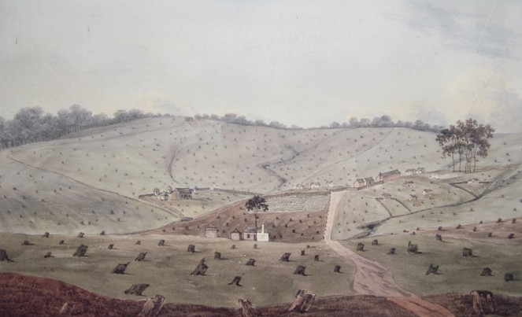

# RESOURCE SHEET 1 - Paintings: Early views of Parramatta and Castle hill

Figure 57: George Street Parramatta from the gates of Government House, around 1804-5 <http://dictionaryofsydney.org/place/parramatta>

Figure 58: Government Farm Castle Hill, 1806 <http://historyservicesnswblog.blogspot.com.au/2011/05/castle-hill-heritage-park.html>

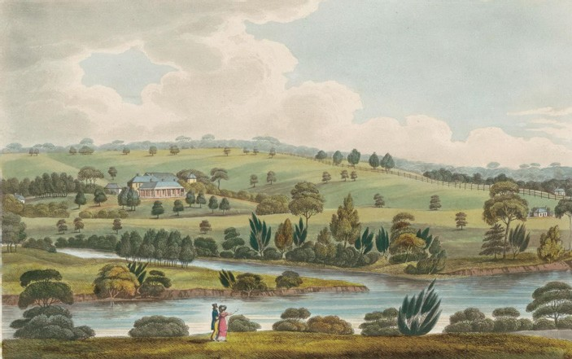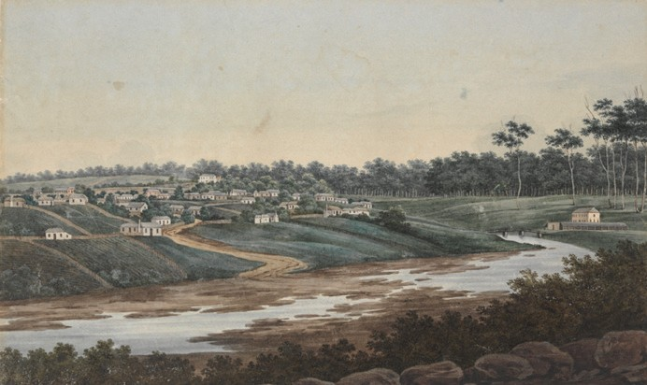

Figure 59: Residence of John McArthur Esq near Parramatta New South Wales, 1825 <http://sydneylivingmuseums.com.au/sites/default/files/styles/heroimages/public/LON10_EFGB_039_2.jpg?itok=SNedhkLx>

Figure 60: A view of part of Parramatta, J.W.Lewin, 1809 <http://www.migrationheritage.nsw.gov.au/exhibition/objectsthroughtime-history/1790-1830/>



# ACTIVITY SHEET 2

### Changing the landscape

Instructions

Look closely at the four paintings from the early colony, then answer the following questions.

|  |
| --- |
| Look closely at the four paintings from the early colony, then answer the following questions. |
|  |
| List five changes the colonists have made to the landscape. |
|  |
| Why do you think these changes were made? |
|  |
| What would be the result of the changes for the colonists? |
|  |
| Does anything of the pioneer remain and where is it e.g. grave, house, monument? |
|  |



# ACTIVITY SHEET 3

### Pioneer research scaffold

Instructions

Choose one of these pioneers from the North West Sydney region to research.

* Matthew Pearce • Richard and Elizabeth Rouse
* George Suttor • Andrew McDougall
* William Joyce • Lalouette de Vernicourt (also known as Baron de Clambe)
* John Smith • Sophia Doyle (wife of Andrew Doyle)

|  |  |
| --- | --- |
| Name of your pioneer: |  |
| Date and place of birth: |  |
| Convict or free: |  |
| When did they arrive in Australia and on which ship? |  |
| When did they receive their land grant and how big was it (acres or hectares)? |  |
| What did they produce on the land? |  |
| What other contribution did they make to the colony? |  |
| Any other interesting facts: |  |
| Does anything of the pioneer remain and where is it e.g. grave, house, monument? |  |
| Provide a relevant image: |  |
| Provide a quote from a relevant source: |  |
| Provide a list of the books and websites you used to find your information. |  |

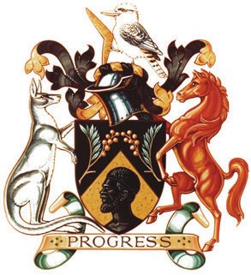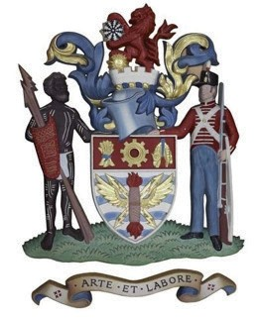

# RESOURCE SHEET 2 - Council crests

D. Parramatta City Council

1. Blacktown City Council
2. Ryde City Council

C. Prospect City Council

1. Hawkesbury City Council
2. The Hills Shire Council

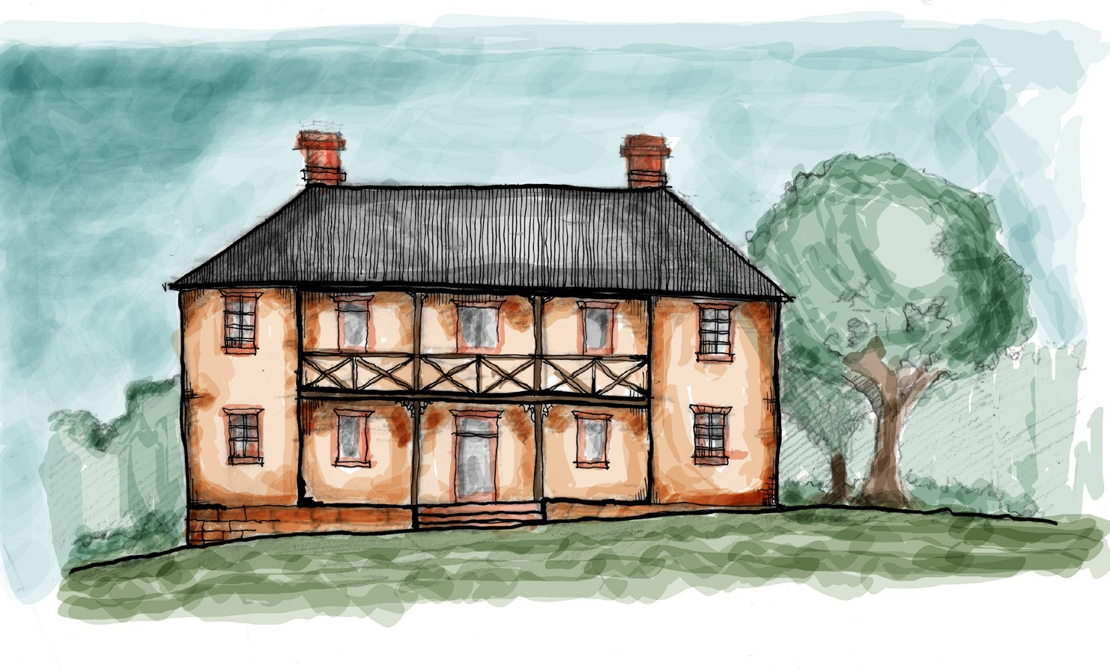

# ACTIVITY SHEET 4

### Information overview: White Hart inn

**Artefacts**

**Location**

**Construction and appearance**

**People**

**Significance of the site**

# ACTIVITY SHEET 5

### White Hart Inn - Sources and evidence

Archaeologists consulted a wide range of sources to determine the likely location of the White Hart Inn and its history. What information could the sources listed below provide to archaeologists about the probable location and history of the White Hart Inn.

Write your thoughts in the boxes provided.





# ACTIVITY SHEET 6

### Working with artefacts

In groups, select 4 artefacts from the identification list and images displayed on the whiteboard. Complete the following artefact grid. Use the information and ideas you have already gathered about your chosen artefacts   
when answering the questions below.

|  |  |  |  |
| --- | --- | --- | --- |
| **1. Draw and identify each of your chosen artefacts** | **2. What does this object reveal about the lives**  **and activities of the people who may have used this object?** | **3. What does this object reveal about the White Hart Inn?** | **4. What more would you like to know about this object? Where might you find this information?** |
|  |  |  |  |
|  |  |  |  |
|  |  |  |  |
|  |  |  |  |



# ACTIVITY SHEET 7

### On the road

The following visual and written sources tell us something about the experiences and dangers that confronted colonial travellers and residents on the Windsor Road. Discuss and complete this activity in groups.

As you examine the following sources highlight words and phrases that are unfamiliar to you or things you need to look up.

Source 1

‘The Roads - A petition was forwarded a few days ago to the Governor, signed by between seventy and eighty persons praying that the road between Parramatta and Windsor may be repaired.

It has for some time back been in a most dangerous state, and while heavy sums are expended on the same line from Sydney to Parramatta, the road complained of is almost totally neglected.’

Source: The Sydney Herald, Tuesday 26 April, 1842, p.2

Source 2

‘Dreadful Accident - On Tuesday evening, as a man named William Adams, a drayman in the employment of Thomas Caddell, Esq., of Windsor, was returning with his teams from Liverpool, and after leaving the White Hart Inn, about half-way between Windsor and Paramatta, his horses from some cause or other ran off, and Adams, after several ineffectual efforts to extricate himself from the dray upon which he was then riding, was at length pitched off, when, with his arms extended on the road, one of the wheels passed over both, producing a compound fracture of the left – and a simple fracture of the right arm.

As soon as intelligence was received in town – Surgeons White and Bell were as soon as possible in attendance, and found it necessary to amputate the left arm. The poor sufferer bore the operation with much fortitude, and is as well under all the circumstances, as can possibly be expected. ‘

Source: Hawkesbury Courier and Agricultural and General Advertiser, Windsor’ NSW, Thursday 27 March 1845, p.2

Source 3

‘Bushranging - Information was lately received by Mr. Shirley, chief constable here, that a bushranger was seen prowling about Mr. Booth’s Inn, on the road between Windsor and Parramatta. No time was lost in dispatching constables to the place, but hitherto they have been unsuccessful in capturing the miscreant.

If however, energy and captivity can avail, there is little doubt of both being put into fearless operation to secure the depredator and bring him to justice. If the information be correct, he, in all likelihood, is not single handed.’

Source: The Sydney Morning Herald NSW, Tuesday 27 September 1842, p.2

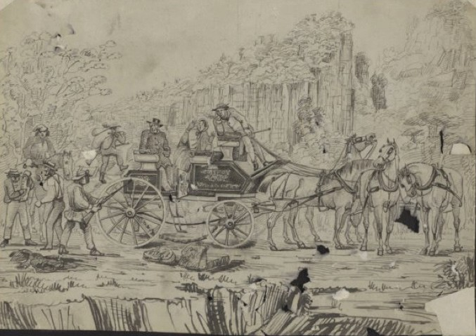

# ACTIVITY SHEET 7

### On the road

Source 4

Figure 61: Bushrangers robbing the mail, George Lacy, 1850, National Library of Australia. Note that the location of this sketch is unknown. Similar coaches travelled the Windsor Road in the 1840s and 1850s.



# ACTIVITY SHEET 7

### On the road

|  |  |  |
| --- | --- | --- |
| **Inquiry questions** | **Evidence**  **(information provided by the source);** | **Thoughts and ideas** |
| What type of source is it? (newspaper report, sketch) |  |  |
| Who created it? |  |  |
| When was it created? |  |  |
| Why was it created? (purpose) |  |  |
| Who was the audience? |  |  |
| What does it say about the dangers and experiences on the Windsor Road? |  |  |
| What is the creator’s point of view? |  |  |
| Can it be trusted? |  |  |



**ACTIVITY SHEET 7**

**On the road**

Colonial newspapers were full of stories about the dangers of road travel and the unnerving experiences of individuals living in isolated places. Use the evidence provided by these sources to write a newspaper report for the colonial ‘The Sydney Herald’ warning travellers and residents about dangers they may encounter on the Windsor Road?



# ACTIVITY SHEET 8

### Historical personalities – Sydney’s North West

**MY PAGE**

**PUBLIC PROFILE**

**IMAGE OF CHOSEN INDIVIDUAL**

**DATE/PLACE OF BIRTH AND DEATH**

**OCCUPATION/S AND STATUS**

**PROFESSIONAL CONNECTIONS AND ACQUAINTANCES**

**OBITUARY**

**TIMELINE OF KEY LIFE EVENT**

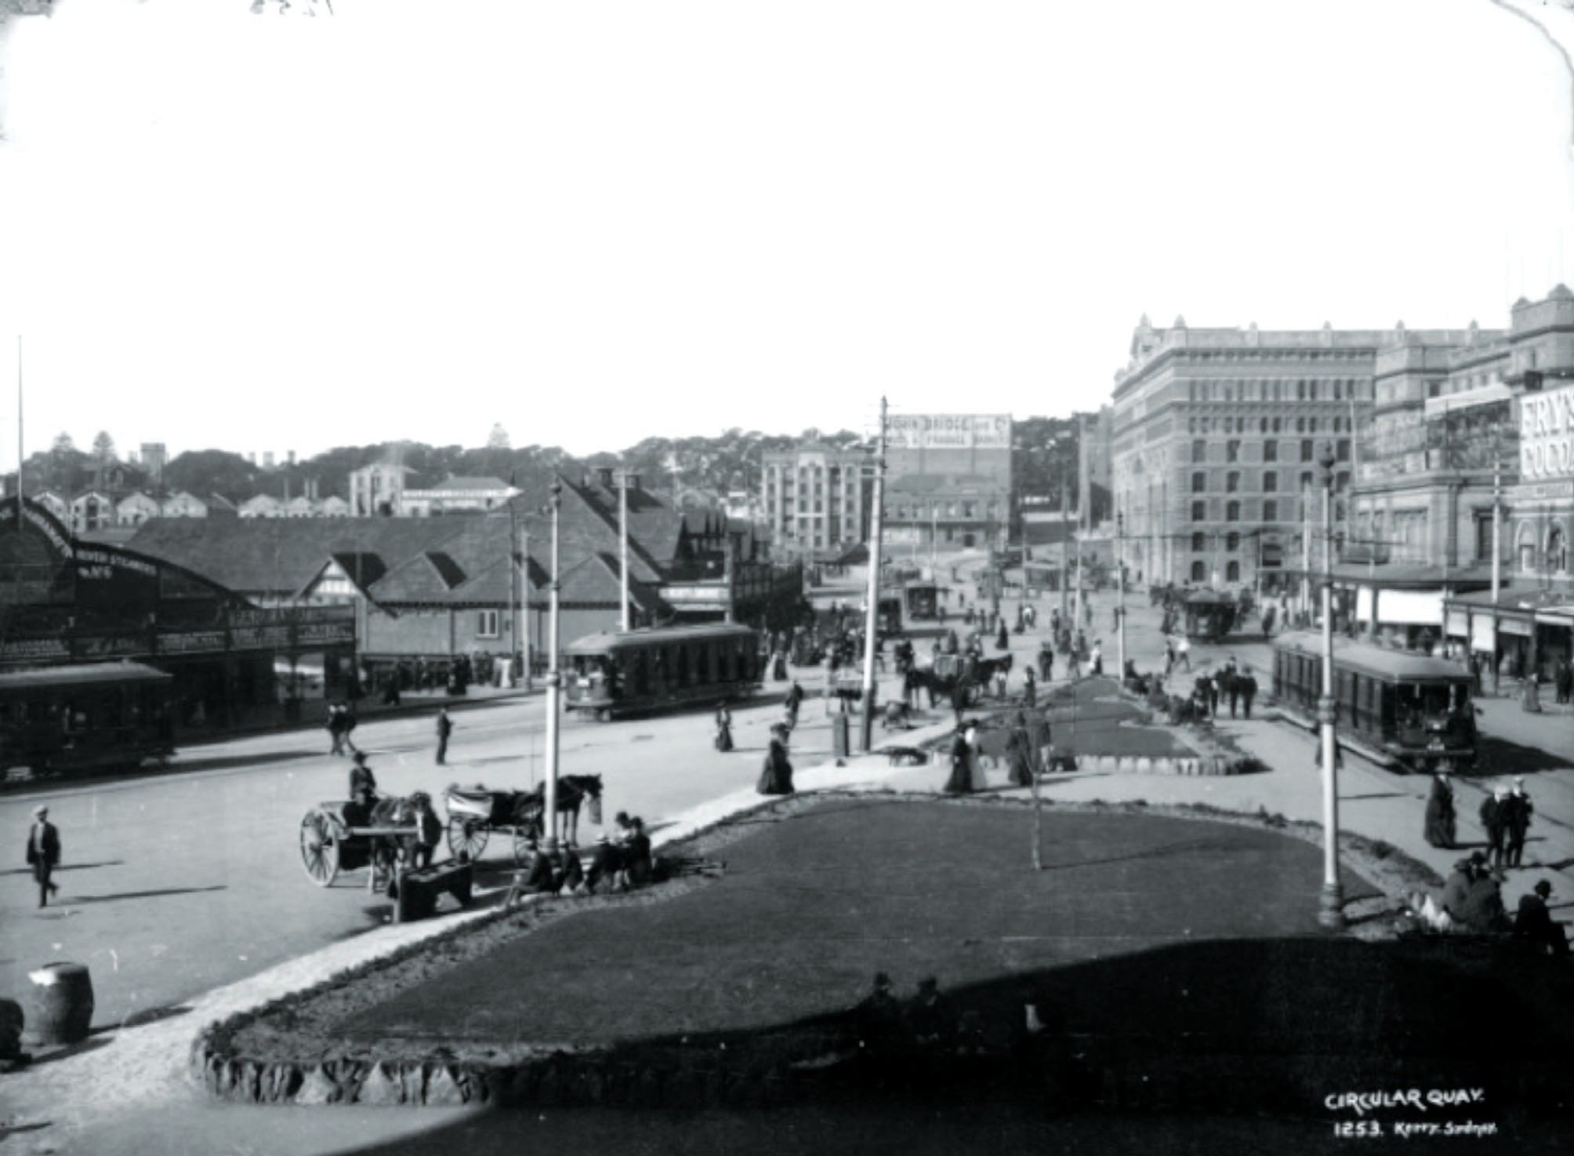

# ACTIVITY SHEET 9

### In the picture

Figure 62: Photograph: ‘Circular Quay’, Kerry and Co, Sydney, Australia, c.1884-1917 (looking east).

<http://www.flickr.com/photos/powerhouse_museum/2758599005>

Take a close look. Can you see evidence of three different forms of transport? Position yourself in the photograph.

 What can you see around you?

 What sounds can you hear?

 What can you smell?

 Why are you there and how do you feel? More about the photo:

[http://www.powerhousemuseum.com/collection/database/?irn=29971#ixzz2RblBZ3x5](http://www.powerhousemuseum.com/collection/database/?irn=29971&amp;ixzz2RblBZ3x5)

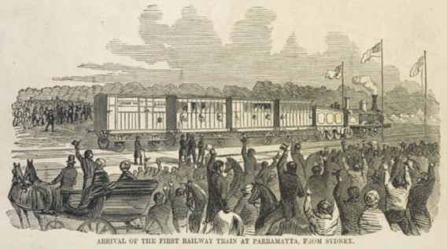

# ACTIVITY SHEET 10

### Anticipated effects of rail

Read the extract from the Sydney Morning Herald article published 4 July 1850. Source 1

### The First Australian railway

“Yesterday the turning of the first turf of the first Australian railway was accomplished, and the ceremony was performed by the daughter of the Governor of the colony, Honourable Mrs Keith Stewart – in spite of the rain, which certainly interfered much with the programme of ceremonies.

He felt it to be a pride and gratification to him, that the first railway in the Southern Hemisphere should be commenced in New South Wales during his administration: for he felt confident, that in-numerable blessings must arise from it, in a social, political, and moral point of view.

The Governor said that he had now to propose a toast, which he mentioned with the most lively satisfaction. It was “The success of the railway.”

It was a fact not generally known, perhaps, that a portion of land, comprising a radius of 140 miles, including the city of Sydney, was occupied by above half the whole population of the colony. If, then, in this sterile district so much good might be effected, why delay the opportunity of doing it. Once established these railways in

the county of Cumberland – to Windsor on one side, to the Cowpastures on the other, and the great scheme of internal communication would be commenced. Then for the first time would they have an interior ‘to the colony, worthy of its out-ports – an interior, to the resources of which they could ‘look with confident reliance. He wished not to see the inland districts of the colony remain a wilderness. By the successful completion of this enterprise, they would be enabled to populate the desert – to create a civilised community in the wild and unpopulated parts of the colony. Then, too, the interior of the colony might be represented by members from the interior instead of the Sydney representation they possessed at present. They might then come to Sydney to perform their legislative duties, but still have it in their power occasionally to visit their families, and attend to their domestic affairs. It had been said that the colonists were not able to carry this enterprise out.”

Source: Extracts from The First Australian railway, Sydney Morning Herald, Thursday 4 July 1850. <http://trove.nla.gov.au/ndp/del/article/12919209>

 List the anticipated benefits of the advent of rail mentioned in the article (Source 1)

 What does Source 2 tell us about people’s reaction to the arrival of the first train at Parramatta from Sydney?

 What expectations do you think early travellers may have held about the new mode of transport?

Source 2

Figure 63: Arrival of the first railway train at Parramatta from Sydney,

Walter G Mason, published 1857. <http://nla.gov.au/nla.pic-an8021264>

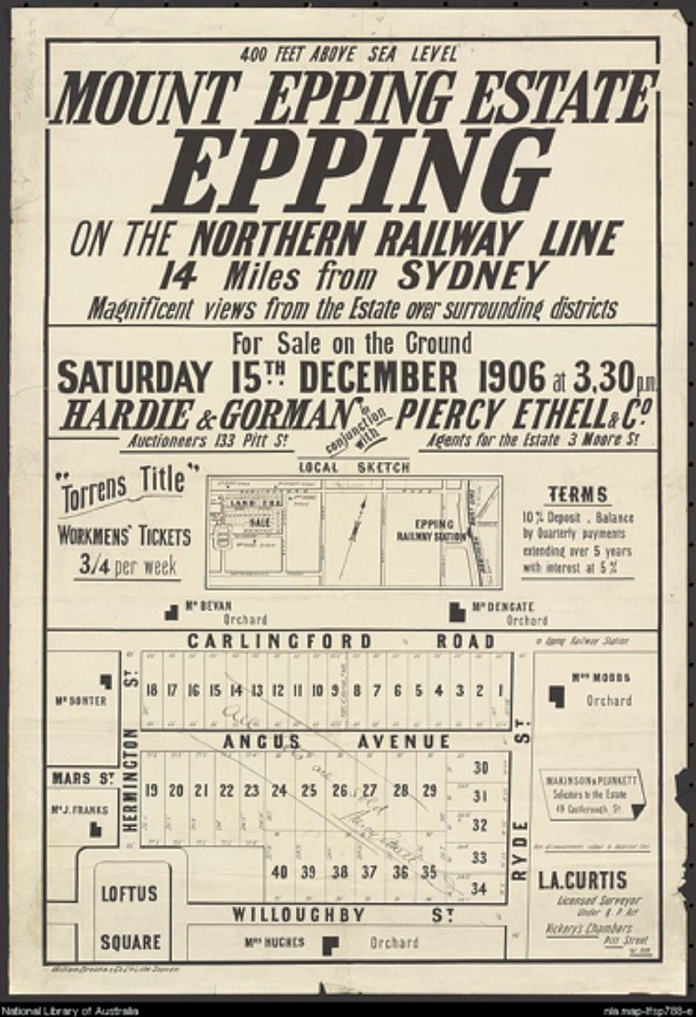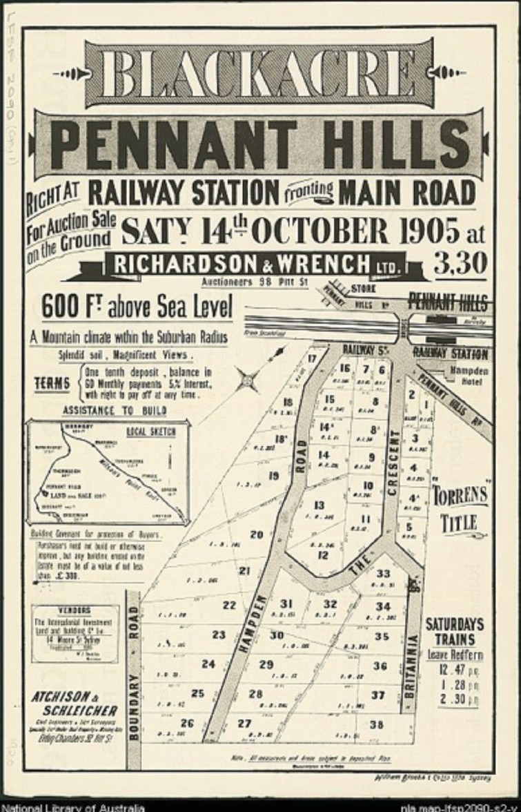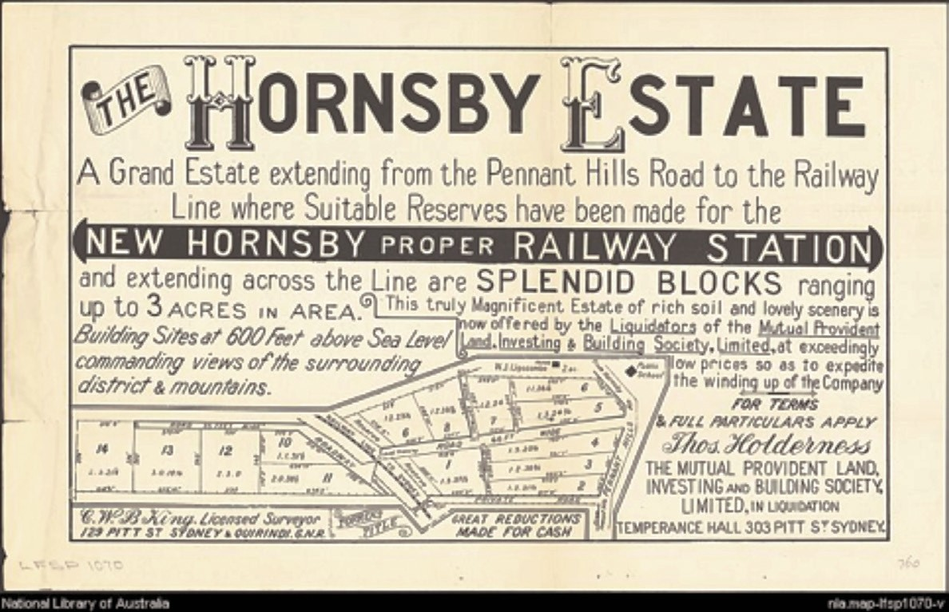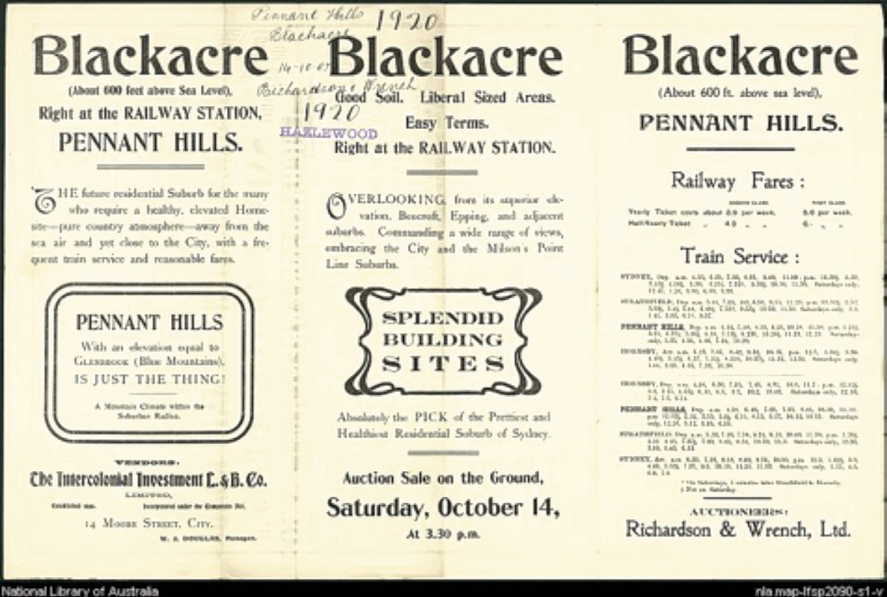

# ACTIVITY SHEET 11

### Great Northern Line land sales

When land was subdivided along the railways what was promoted to Sydney’s population?

Mount Epping Estate <http://nla.gov.au/nla.map-lfsp788>

Blackacre brochure <http://nla.gov.au/nla.map-lfsp2090-s1>

Blackacre poster <http://nla.gov.au/nla.map-lfsp2090-s2>

Hornsby Estate <http://nla.gov.au/nla.map-lfsp1070>

Figure 65: Mount Epping Estate.

Figure 64: Hornsby Estate.

Figure 66: Blackacre poster. Figure 67: Blackacre brochure.

# ACTIVITY SHEET 12

### Suburban patterns

Using a different colour for each, show the main land uses on the 1943 aerial photograph of the Great Northern railway line between Epping and Pennant Hills https://maps.six.nsw.gov.au

KEY

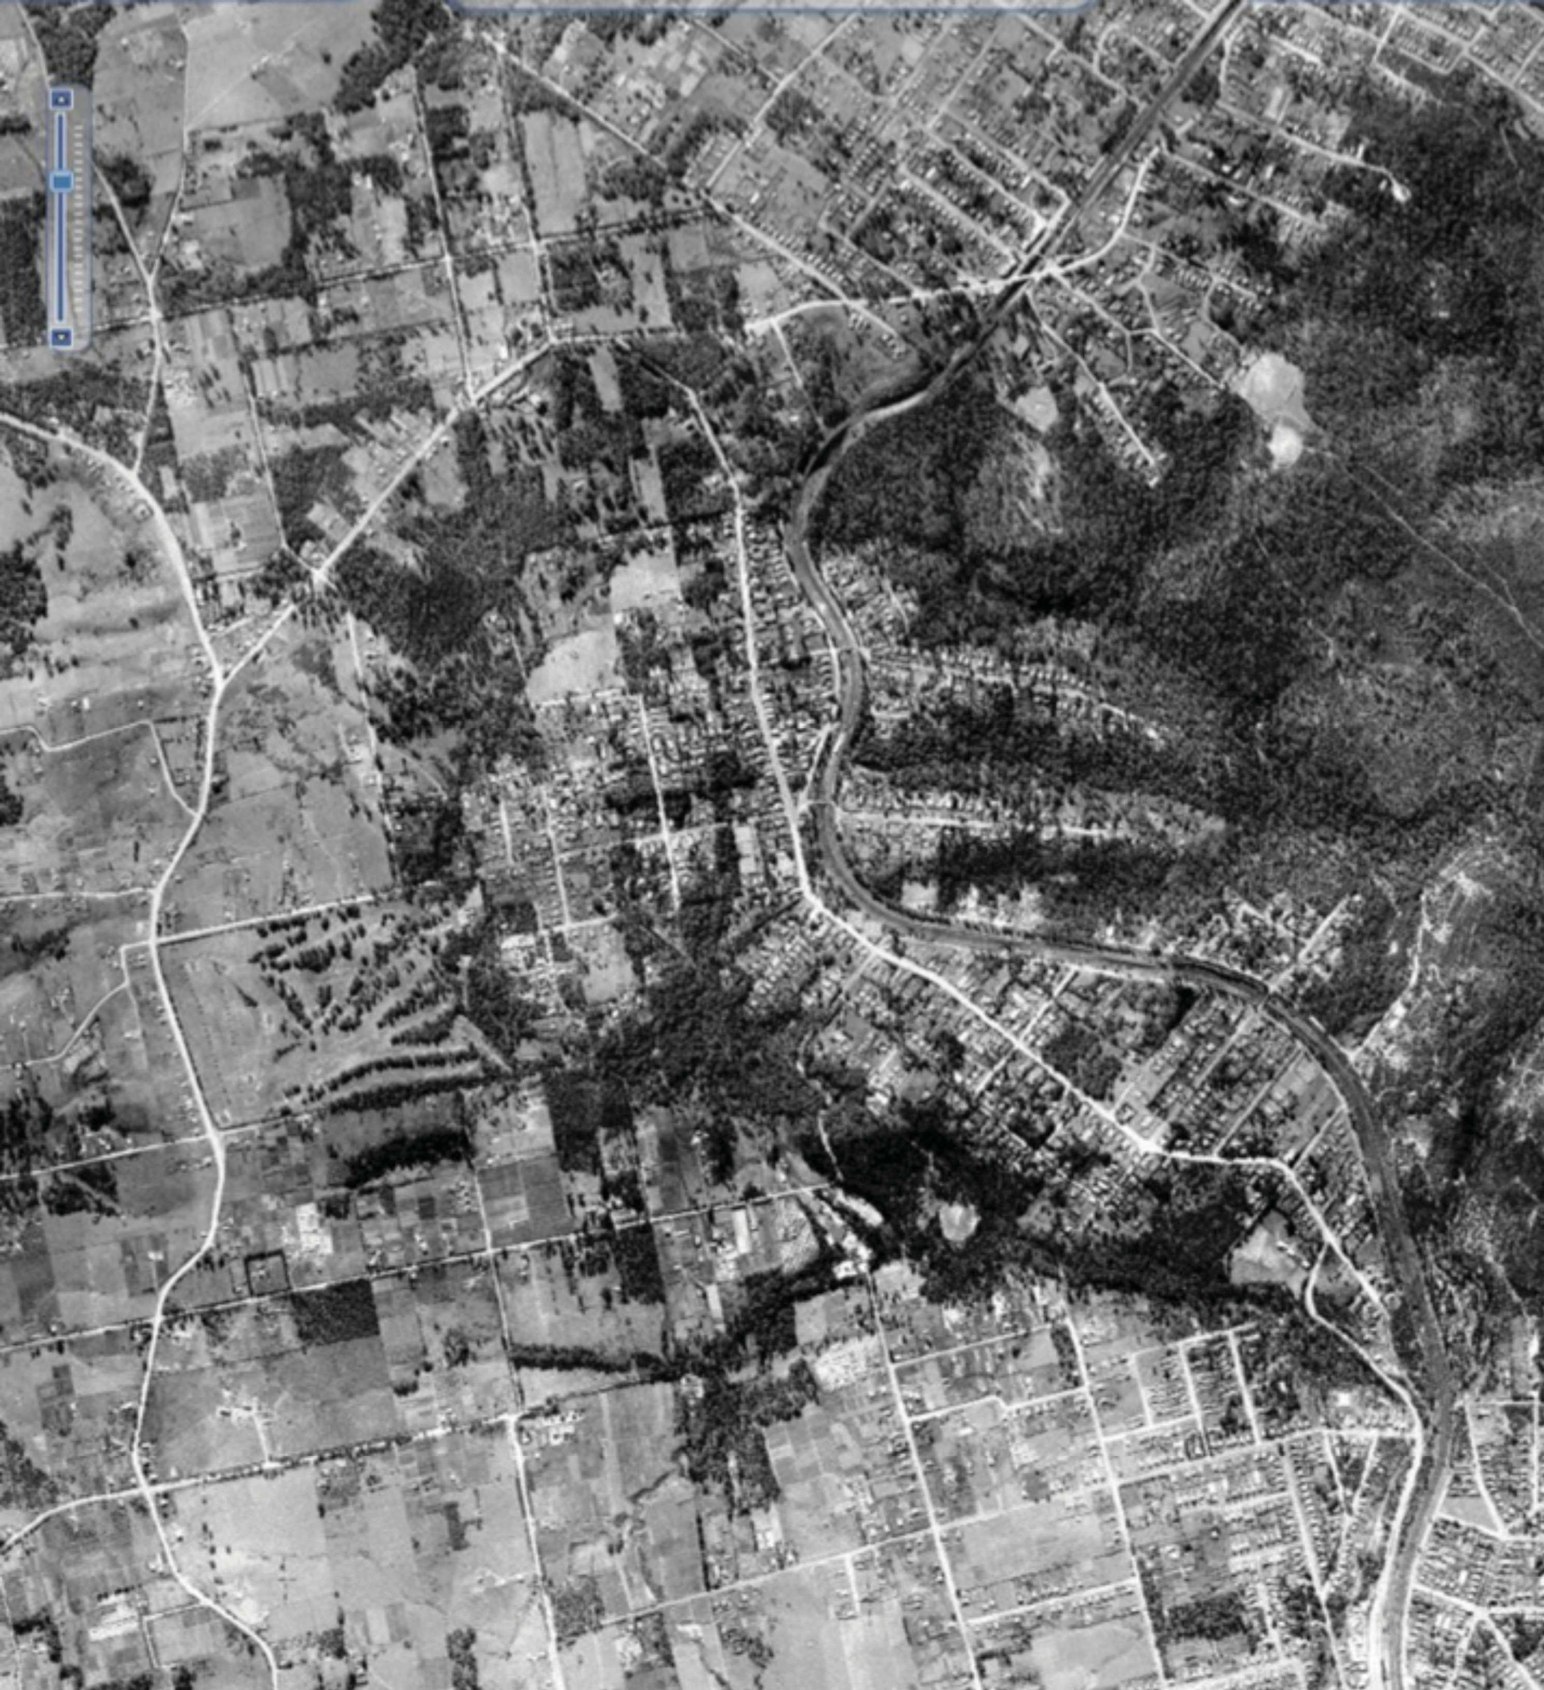

Railway Housing Farmland Bushland

**ACTIVITY SHEET 13**

### Virtual journey along the Rogans Hill – Parramatta railway line

Research the Rogans Hill – Parramatta railway line. Develop two to three inquiry questions to guide your research. Create a virtual journey along the line. This may be a series of past and present images or a re-telling of the journey from the eyes of an original passenger or tram or train driver.

Secondary sources Summary of the line’s history

<http://www.westernsydneylibraries.nsw.gov.au/westernsydney/rail.html>

Primary sources

Oral history by Bruce Irwin   
http://www.thehills.nsw.gov.au/Library/Library-e-Resources/Hills-Voices-Online/Changing-Shire/Bruce-Irwin

Oral history by Enid Davis   
http://www.thehills.nsw.gov.au/Library/Library-e-Resources/Hills-Voices-Online/Changing-Suburbs/Northmead-Enid-Davis

Land Subdivision Posters

<http://www.thehills.nsw.gov.au/Library/Library-e-Resources/Local-Studies-Family-History/Historical-> Subdivision-Plans-of-The-Hills-Shire/Castle-Hill-and-Glenhaven-Subdivision-Plans

Google Maps https://maps.google.com.au



## **ACTIVITY SHEET 14**

### Resource links

**Sydney Metro Northwest – resources**

Resource links

Sydney Metro Northwest website [www.sydneymetro.info/northwest](http://www.sydneymetro.info/northwest)

Sydney Metro Northwest Project Overview June 2014 [http://nwrail.transport.nsw.gov.au/Info?type=Publications&keyword=project%20overview](http://nwrail.transport.nsw.gov.au/Info?type=Publications&amp;keyword=project%20overview)

Media Release (20 June 2012)

<http://www.nwrail.transport.nsw.gov.au/NorthWestRailLink/media/NWRL/Original/media%20releases/> NWRL_media_release_1 1.pdf

Sydney Metro Northwest Corridor Strategy

<http://www.planning.nsw.gov.au/Plans-for-Your-Area/Priority-Growth-Areas-and-Precincts/Sydney-Metro-> Northwest-Priority-Urban-Renewal-Corridor

The Growth Centres <http://growthcentres.planning.nsw.gov.au/PriorityGrowthAreas/NorthWestPriorityGrowthArea.aspx>

Daily Telegraph (30 October 2012)

<http://www.dailytelegraph.com.au/news/sydney-news/new-rail-line-to-slash-car-trips/story-> fnb5f12x-1226506641713



# FUTURE ASSESSMENT TASKS

Students reflect on their learning over the unit of work and complete the ‘what I have learnt’ column.

|  |  |  |
| --- | --- | --- |
| **What I know** | **What I want to know** | **What I have learnt** |
|  |  |  |
|  |  |  |
|  |  |  |
|  |  |  |
|  |  |  |
|  |  |  |
|  |  |  |
|  |  |  |
|  |  |  |
|  |  |  |
|  |  |  |
|  |  |  |
|  |  |  |
|  |  |  |
|  |  |  |
|  |  |  |