ACTIVITY SHEET 1
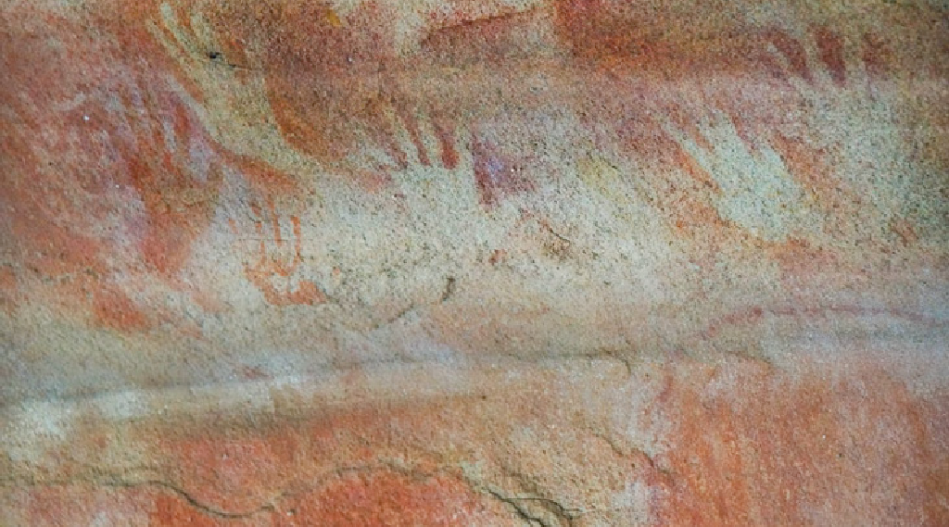
Hand Stencils

Equipment
 Paper plates (optional)
 2-3 metre length of paper or fabric
 Tempera paint diluted 50/50 with water
 Spray bottle

Steps
Show students a range of examples of Aboriginal hand stencils so they understand what they are aiming for.
Explain how Aboriginal people made the stencils – by filling their mouths with a mixture of ochre and water, then spraying it over their hand held against the rock.
Explain that for safety reasons they will be using a slightly different method.
- Students place one of their hands on a sheet of paper, trace around it and cut it out.
- For individual stencils, students place their hand cut-out on a paper plate.
For class stencil, students arrange their hand cut-outs on a length of firm paper or fabric
- Add diluted tempera paint to a spray bottle
- Squirt lightly around each hand. Let dry thoroughly.
- Remove the hand cut-outs.

Tips
Black, white or yellow paint looks good against cream or ochre coloured paper or fabric.

Figure 10: Aboriginal hand stencils, Red Hand Cave, Blue Mountains National Park, believed to be between 500 and 1600 years old. National Parks NSW: http://www.nationalparks.nsw.gov.au/things-to-do/Aboriginal-sites/Red-Hands-Cave

56 WORKSHEET – TOPIC ONE: A RAILWAY FOR SYDNEY’S NORTH WEST REGION

ACTIVITY SHEET 2
Bidjigal Reserve Map

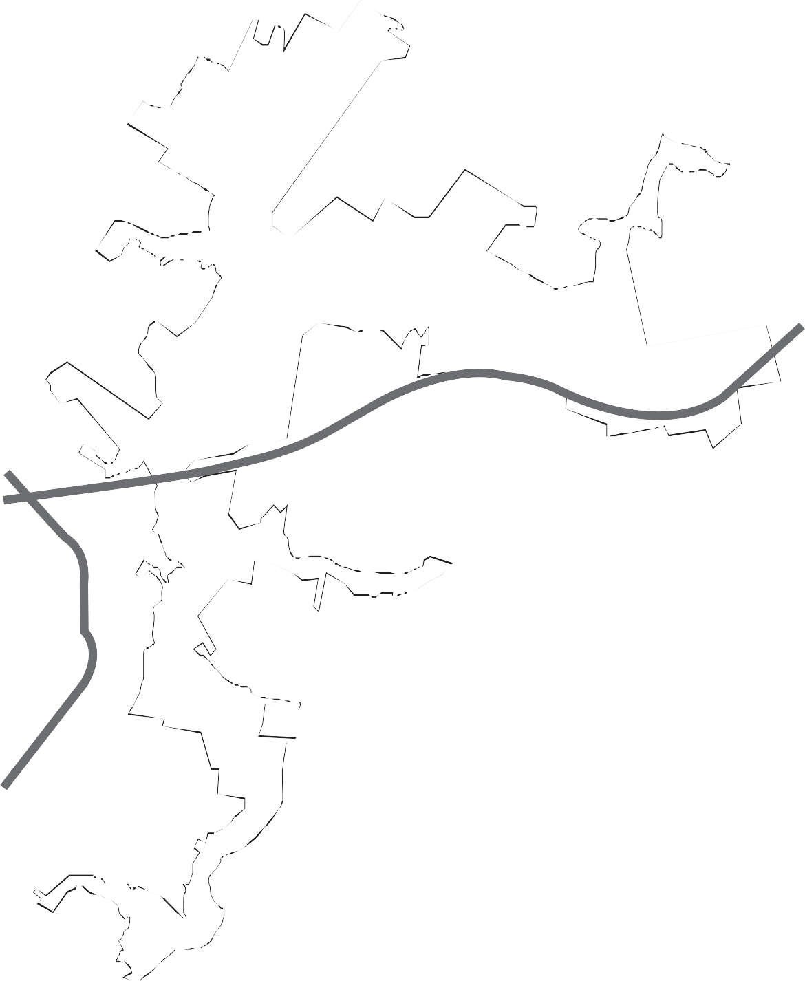
Castle Hill

P

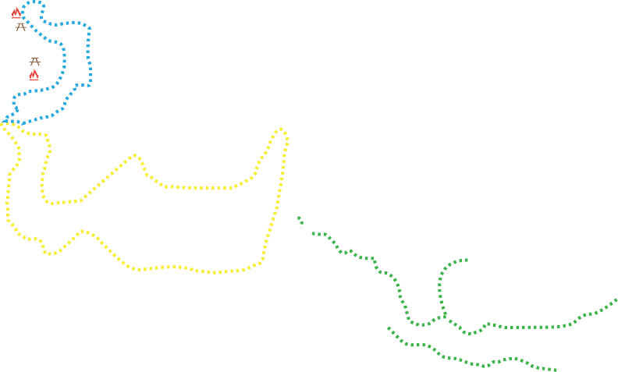
P
P T
Eric Mobbs Reserve
P

P
West Pennant Hills

Richard Webb
Reserve

Baulkham Hills

Bald Hill

Bidjigal Reserve
& Surrounding Bushland
P

P T
Ted Horwood
Reserve

P Bidjiwong Community
Nursery

M2 Motorway

North Rocks

Windsor
Road

Carlingford

Northmead P

The Convict Road

P

Instructions
Shade reserve land green and built-up area pink
Create a key showing reserve land and built up area, major roads and three walking tracks, Burraga (yellow); Platypus (blue); Murri-yanna (red); Other tracks (green)
Include parking, barbeque, picnic facilities, playground and toilet

FASTTRACKING THE FUTURE | PRIMARY EDITION NOVEMBER 2016 57

